The Great Wooden Dike at Leland Neck
by Fred Chaney

Fred Chaney contributed to the Mississippi Department of Archives and History copies of several Mississippi River stories. These manuscripts are titled, “The Mississippi Valley Flood of 1927—As Seen By A Box-Car Refugee,” “A Refugee’s Story,” and “The Story of the Great Wooden Dike at Leland Neck.” According to Chaney, the Great Wooden Dike story was given to a family member to make copies and return to the Department of Archives and History, however it was never returned to Archives nor were any copies located.
However, his description of the Leland Neck break was in a 1957 letter to A.S. Coody. The story of the Great Wooden Dike at Leland Neck tells of the futile effort to prevent the Mississippi River from completing its cut-through at “Leland Neck” and forcing Greenville back on a lake, later to be called Lake Ferguson. The Mississippi River Commission’s (MRC) policy was to “prevent the Mississippi River from making natural cutoffs in the Greenville Bends area, but the Mississippi overruled the Commission.”
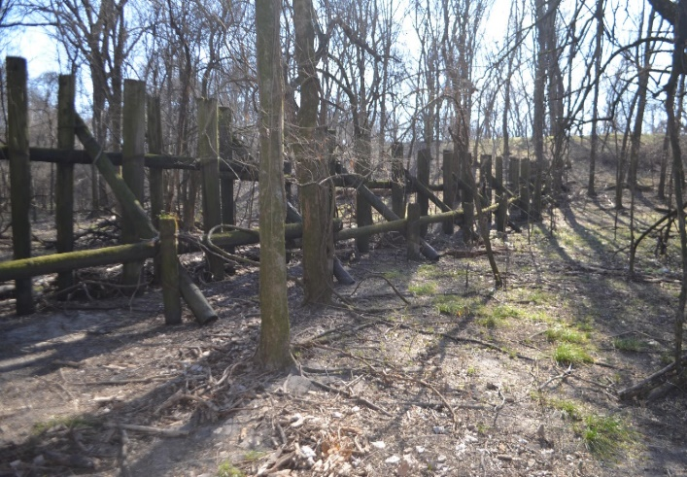
Cut-offs were created to shorten the river and reduce flood heights while dikes directed the flow of the river. “The river had threatened to break through the [Leland] neck for decades.” Erosion in 1903 reduced the distance of the bend “prompting the MRC to construct a 6,250-foot-long protective [wooden] dike along the axis of the neck.” The wooden dike was extended by a half a mile but by 1910 was shrunk to 2,600 feet. “[F]furthermore, the floods of 1922, 1927 and 1929 began scouring an elongated trench across the neck, leading the MRC to connect the existing dike with a mile-long permeable dike.” Permeable dikes were less durable than stone dikes and were typically composed of posts and piles. In addition, a considerable amount of concrete revetment had been placed on the banks.
Photo courtesy of Peter Nimrod, MS Levee Board. Permeable Timber Dike still standing in Bolivar County.

On June 3, 1933, the Mississippi River broke through the permeable pile dike built to prevent a cutoff at Leland Neck. The Corp of Engineers approved the Leland Cut-off and “a tower machine cut a large channel from the blue hole to the Mississippi River (lower side)” and “[o]n July 8, 1933, the Lower Mississippi cut its way across a narrow neck of land at Leland Plantation and abandoned its old bed in Bachelor Bend. Divorced from the river were Island 83 and the town of Greenville, Mississippi.”
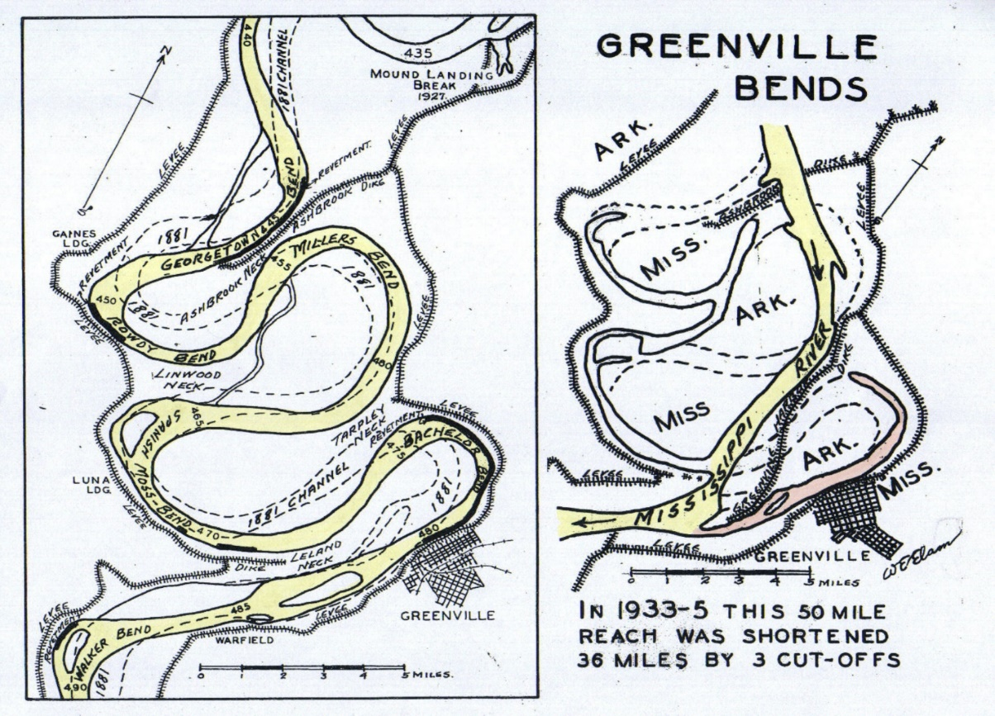
Figure 1W.E. Elam, "Speeding Floods to the Sea or The evolution of Flood Control Engineering on the Mississippi River
The drawings above of the Greenville Bends shows on the left, the Leland Neck wooden dike, and on the right a drawing showing the dike broken apart.

The following story of the wooden dike at Leland Neck is Fred Chaney’s description of the destruction of the wooden dike as told in a letter to Mr. A. S. Coody, dated July 16, 1957. Mr. Coody wrote articles and letters to the editor of the Jackson newspapers. Chaney said that he had long been a reader of Coody’s letter contributions to the Jackson papers and admired the detailed knowledge of history and the many subjects in which he communicated.
The letter to A. S. Coody covered numerous subjects including the Leland Neck story and that selection is included in its entirety and has not been edited. Details of the height and width of the wooden dike he describes in his story could not be confirmed.

* * *

The Story of The Great Wooden Dike at Leland Neck

“…The leaking dike built entirely of titanic wooden piling thrown up there in the face of the Mississippi which was calculated to slow the river down and cause the sediment drifting down to fill up the hole gouged across the neck and thereby prevent the town of Greenville from being shunted aside from the main channel of the river. The project was successful for several years and then the River rose in its might to great heights against that defying partial barrier in the path of its strongest currents on the third Spring after construction of the Great Leaking Dike and blasted it to pieces.
And although it was seventy feet high and sixty feet through (thick) and cost over a million dollars – though fashioned of nothing but giant piling and giant timberings, criss-crosses and bolted to the piling there – and looked good for twenty years resistance against the Mississippi as engineers had said it would be – on that third Spring following the Mississippi as engineers had said it would be-on that third Spring following its ingenious creation it was blasted out of existence by the might of the Mississippi – it became only match-wood.
I wrote its story – perhaps the only account ever made about it save as to engineering Government records. It was certainly a unique engineering attempt in flood control since it’s construction represented probably the only FRONTAL ATTACK in FLOOD CONTROL PROJECTS ever to be attempted against the Father of Waters.
I had worked on it and knew its trails in building in detail I knew the story of the river’s final assault and the Dike’s dramatic destruction. I knew also of the heroics of one man J…P…who when the Dike was disintegrating from the tremendous weigh of the Mississippi had taken a light boat and gone to the rescue of three men fighting for life there among the great hurdling timbers of the crumbling great LEAKING DIKE and knew too, that this same hero in later years, on account of a blood disease had been sent to Whitfield as a patient.
So I wrote it’s story and used it’s writing as a cover-up screen for smuggling out mail describing awful conditions at the hospital. So in that way the river experience helped me to get the story to the world outside of our own tragedies here in Whitfield – during ’46-’49. I asked unsuspecting attendants to carry out mail for me about THE DIKE story they knew I was writing. What they mailed was not THAT STORY.
Proving that truth is stranger than fiction I finished The Dike story while confined in a “tight-room” at the disturbed building “High 5” where at that time I was being punished for helping Robert L. …(veterinarian) hack-saw his way free from back there-taking out forty six letters that I had written state leaders about conditions of life at Whitfield.”
* * *

When Fred Chaney was discharged from Whitfield, he lived at the old Governor Lowrey home in Jackson. It was here that he “typed off the Flood Disaster of ’27 Box-car refugee’s story and the story of THE GREAT WOODEN DIKE AT LELAND NECK and sent them to Dr. McCain the then director of the Archives and History Department. Later these copies were withdrawn for recopying and were misplaced.”
Chaney wrote a letter to Brodie Crump, columnist with the Delta Democrat-Times asking if he had a copy of the Leland Neck story. The following excerpt from the letter has not been edited:
“I have tried to trail down a copy of the story I wrote once out here about the great wooden dike built at Upper Leland neck whose purpose was to prevent Greenville from being shunted off the regular river channel by the cut-through process going on. I had sent a copy to the Archives of History Department together with the Refugees Flood account that I made of the experiences we had in the ’27 Flood. Later on I withdrew the manuscript at the request of Helen House -- my aunt in Cleveland -- and now it has been misplaced or lost up there -- and I can’t find a copy. Mr. McCain wrote me a letter of thanks for the contributions and later wrote again to say that he had included a resume of them in a book of his own concerning some of the material available in the Department for research.
It occurred to me that maybe I sent a copy of that Dike manuscript to you and that I could get it now to mail to the Archives to replace the one with-drawn. I believe it is the only written [illegible…] manuscript is not very good – but the only one of it’s kind -- and about a job unique in the river history at least of Greenville. If you have one and will send it here or to the archives I will be very glad. I hope that they have a copy of your own newspaper accounts of the Great Flood --which were even better, I thought than Will Percy’s Flood chapters.”

* * *
During the Mississippi River flood of 2011, John Ruskey, the Delta Bohemian and his Quapaw Canoe Co. in Clarksdale, Mississippi, photographer Christopher LeMarca, and W. Hodding Carter, grandson of the late owner and editor of the Delta Democrat-Times, while ignoring Governor Haley Barbour’s executive order to stay off the Mississippi River, canoed 300 miles from Memphis to Vicksburg. Carter stated “[t]hat night we camped at a place on the Mississippi that I knew from childhood…it was a steep, 30-foot-tall set of sandy bluffs at Leland Neck…Always a natural beacon in the flattened Delta landscape, it was also, on the night of May 17, the only piece of dry land for miles…Nonetheless, the former cliffs, now short, tiny islands, were awash in sunset glow…”

Marion Bragg, Historic Names and Places on the Lower Mississippi River, p.130, Mississippi River Commission, Vicksburg, 1977.
Charles A. Camillo and Matthew T. Pearcy, Upon Their Shoulders, A history of the Mississippi River Commission from its inception through the advent of the modern Mississippi River and Tributaries Project, p. 211 Mississippi River Commission, Vicksburg, Mississippi, 2004.
Ibid.
Ibid.
Marion Bragg, Historic Names and Places on the Lower Mississippi River, p.129, Mississippi River Commission, Vicksburg, 1977.
Ibid.
W. E. Elam, Speeding Floods to the Sea or The Evolution of Flood Control Engineering on the Mississippi River, The Hobson Book Press, 1946.
Mr. Coody had been an assistant to the Capitol Commission under Governor Bilbo’s administration, and worked for the State Tax Commission for many years. He was also the author of Biographical Sketches of James Kimble Vardaman.
Fred Chaney, letter to A.S. Coody, July 16, 1957, Fred Chaney Papers, MDAH.
Fred Chaney, letter to Brodie Crump, May 28, 1955, Box 1, Folder 18, MSS 654, Brodie S. Crump Family Papers, Manuscripts Division, Special Collections Department, Mississippi State University Libraries.
W. Hodding Carter, “57 Feet & Rising,” Outside Magazine, August 2011 Issue, June 29, 2011.

