The Mighty Mississippi River

Steamboat Trips on the Mississippi

__________________________________________________________________
Fred Chaney wrote a letter to Brodie Crump with the Delta Democrat-Times on May 28, 1955 describing steamboat trips on the Mississippi River with Charlie Allen II, his childhood friend and cousin from Rosedale, MS. “The steam-boat trip that Charlie Allen II and I took as kids aboard “The Arthur Hider”—along with our parents—one Sunday at the invitation of Cap’n Haynes—who, often in those days was a guest in the Allen home in Rosedale—and the fried chicken dinner and watching the banks of the rising river caving—and watching the sunlight make rainbows in the spokes of the churning side-wheels of that boat – all these come back at mention of Cap’n Haynes. This was not the first river trip for us on board a steamer but it was close to the first and enough thrills about it to remember for a lifetime. There never was a more gracious host than Cap’n Haynes-and in those days he was a great favorite around Rosedale with young and old alike. It is good to be reminded of him and the memories that his name recalls.

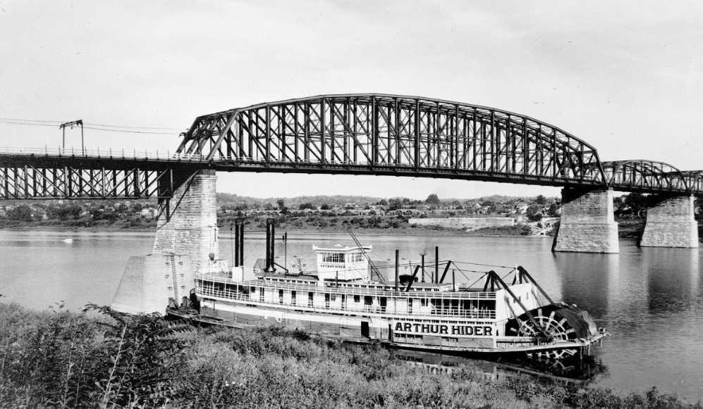
Figure 1 Image courtesy of Murphy Library Special Collections/ARC,
University of Wisconsin-La Crosse

Later I worked on the River with two of his sons--and Aubrey (his oldest boy) who married a Spanish senorita and the others made a family of four boat masters on the old Mississippi quite a unique record for River men anywhere.
While thinking of the Miss. let me tell you now about the time mama took Rife [Fred’s brother]and me to Memphis aboard the Kate Adams –some time before the Arthur Hider trip – with Cap’n Haynes – There were several trips on the Arthur Hider but for us that trip to
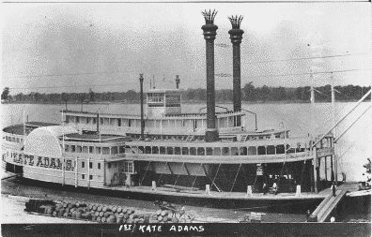
Memphis was the first time I guess that Rife had ever been hoisted anywhere in an elevator. So when we got into The Peabody [landmark hotel in Memphis, TN] and it started to move he hollered “Mama let me
Figure 2 Image Courtesy of Murphy Library Special Collections/ARC, University of Wisconsin-La Crosse

out of this little room – it’s come aloose.” Later on when he was let out and we were settled in the hotel room Rife pointed at the cord with the electric light dangling from the ceiling – and said, “look at that lamp chimney hanging on that string” –But he had only beat me to such vocal reactions about those wonders –and Charles Allen II too. There in Memphis we felt just as country and strange as they come. I’ll never forget how scared I was standing on the deck of the Kate Adams waiting for the certain doom of the crash coming as her smoke stacks would hit the Harahan bridge -- It looked so impossible for the boat to get under from a kid’s eyes (as she approached the awesome bridge--)
* * *
There were three Kate Adams’ steamboats. The third steamboat was built in 1903 and traveled the Mississippi River for 24 years. She had a run from Memphis to Arkansas City and after 1926 she had a run from Memphis to Vicksburg. “She was chartered by the Universal Films Company for the filming of “Uncle Tom’s Cabin… and two months later burned at her moorings in Memphis.”

Captain Aubrey D. Haynes was the Master of the sternwheeler in 1919, https://digital.library.wisc.edu/1711.
Letter from Fred Chaney to Brodie Crump, May 28, 1955, Box 1, Folder 18, MSS 654, Brodie S. Crump Family Papers, Manuscripts Division, Special Collections Department, Mississippi State University Libraries.
Florence Warfield Sillers, History of Bolivar County, Mississippi, Copyright 1948, The Reprint Company, Publishers, Spartanburg, South Carolina, pgs. 206-207, 1976.

