Mississippi’s Waterways

Fred Chaney brought attention to the industrial potential of Mississippi’s waterways through personal letters and editorial letters to newspapers. He corresponded with Representative Karl Wiesenburg from Pascagoula, Mississippi to discuss his support of using the state’s natural inland waterways for industrial use and for transportation facilities. The waterways he said, could provide state-owned and operated permanent hydro-electric power stations, and cheap water transportation utilizing the rivers, and providing coastal seaports. It is believed that Chaney first discussed his proposal with Representative Wiesenburg starting with a letter campaign, followed by the development and printing of a pamphlet that discussed Mississippi’s waterways, his work-for-pay proposal, and mental health issues at Mississippi State Hospital at Whitfield.
* * *
Otto Karl Wiesenburg, born in New York, joined the Coast Guard and was assigned to the Coast Guard base in Pascagoula, Mississippi. It was here that he envisioned the “city’s development as a port would create jobs and new economic opportunities, and he wanted to be a part of this future…he decided to become a lawyer, believing this profession would provide a path to his helping shape the future of Pascagoula.” He provided legal work for Ingalls Shipyard in 1938, and continued his plan to develop a seaport for international trade. In 1941, he persuaded the Jackson County Supervisors to create the Pascagoula Port Commission and he became its first chairman.
The state legislature passed legislation authorizing the commission to issue $2 million in bonds for the dredging of Pascagoula Bay, however legislation “did not authorize acquiring land, securing additional funding, or managing port operations…He believed the board of supervisors and the city of Pascagoula would not move towards new legislation that would create a strong port commission. He decided he would be best suited to become a candidate for the state legislature with creation of a strong port commission as his primary goal.” Wiesenburg won his election and served in the Mississippi House of Representatives from 1956 until 1964.
Representative Wiesenburg pushed through legislation for the Jackson County Port Authority Act of 1956 and the State Port Act of 1958 which allowed other cities on the Gulf Coast to become seaports. He was considered to be the father of the Port of Pascagoula.

* * *
The following letter to the editor was published in the Delta Democrat-Times on May 16, 1957. Fred Chaney did not include his name in the letter, but it was written and submitted by Fred Chaney and can be found in the Fred Chaney Papers at the Mississippi Dept. of Archives and History. Excerpts from the letter have not been edited.

“Letter to the Editor
Reader Says State Is Ignoring Development Of Its Waterways
I would like to ask Mississippians who are supposed to be sane and responsible adults why they allow themselves to become led into thinking that constitutional changes, tax reductions, or other legalistic tricks of enticement will bring them the industrial wealth and opportunity that our present leadership is so desperately seeking.
…Or is it not plain too, that other richer states can out-match our own in this kind of competitive bidding for industrial enterprise?
The one great natural advantage that we do have to place into the competitive game and which few states CAN MATCH are our many water-ways – our undeveloped ports and rivers.
How much longer can we afford to ignore them?
The citizens of Jackson County have shown the real way to get quick response from the vast industrial held outside of Mississippi’s borders.
The citizens of Jackson County simply by a county-wide sponsorship of deep channel development at Pascagoula costing less than five million dollars have already gained in return on this investment location contracts of industrial enterprise worth more than twenty million dollars. This county too, has shown a substantial increase in its population –the only county in Mississippi not lagging appreciably in industry and in population – lately.
What outside industry is interested in primarily is cheap and permanent power supply – cheap and easy means of transportation. These basic advantages have in time the “pulling power” of most any other considerations.
Not only is this being ignored by Mississippi’s refusal to use and exploit its power and transportation natural facilities (rivaled by few states) – but the truth, too, is being ignored that the conversion of our water-way resources is the only way to guarantee an evenly developed industrial economy throughout all sections of Mississippi.
It is fundamental to the welfare of our water blessed commonwealth that state-provided power and transportation advantages must be claimed and used the same way that all the people of the state claim, provide and use their roads and highways, their bridges, and schools. All citizens need these essentials as part of its commonwealth, public property and ownership for the benefit and use of all.
…This will mean more money and more improvements of every kind for all who live in the great state of Mississippi, so naturally blessed beyond as many more states in the great ways pointed to here.
Name Withheld By Request”

* * *
Fred Chaney carried the theme of developing the waterways with the following letter to Representative Karl Weisenburg. Chaney’s letter of June 23, 1957, was in response to a letter he said he received from Rep. Weisenburg. The letter from Rep. Weisenburg has yet to be located, but it is obvious that they corresponded with each other on Chaney’s waterway’s proposal and support. The letter has not been edited.

Whitfield, Miss. June 23, ‘57
Rep. Karl Weisenburg- [the correct spelling is Wiesenburg]
Pascagoula, Miss.
Dear Mr. Weisenburg-
Your very gracious letter of June 20th setting the seal of approval on the opinion expressed in my previous communication to you concerning the necessity of Mississippi taking charge-by legislative action-of it’s greatest natural resources, it’s unrivaled water-ways, with the purpose of developing their industrial potential, was a highly significant and important letter for me to have received. For, that Mississippi sooner or later MUST exploit the advantages of it’s unused waterways has become a plainer and plainer truth as we lose population and begin to lag behind other states in industrial growth. Or, as you say, it is just the “common-sense” way that the whole state has open before it to begin to receive similar benefits as Jackson County alone is now doing by the imaginative action taken at the county level that has secured for it’s citizenship the blessings of a single deep channel port (a transportation facility that after the original investment of approximately $5,000,000 has already repaid many times over that amount in the attracting there of multi-million dollar business enterprise and in the coming of more and more desireable citizens into Jackson County.
It is only a matter of common sense, also, therefore, that outside business interests weighing the attractive qualifications of a prospective Mississippi location (other than the favorable climate we may always offer here) that these interests would be influenced and pulled toward us mightily if there were to be found HERE the best in cheap and permanently guaranteed POWER supply- (hydro-electric)--the best in cheaply provided and permanent transportation facilities (easily navigable rivers and ports)
Advantages that Mississippi will NEVER be able to offer the searching inventory eye of industry-on-the-move UNTIL state development of Mississippi’s inland waterways, coastal and river ports has become the industry and to all of us that it’s reality in being and blessed truth in fact would mean///
As for our state-wide handicaps of continuing to tolerate coporate or private control of such universal a necessity as POWER SUPPLY - might we not just as reasonably turn over also to coporate or private interests (and with it the right to fix any price for use they may wish to share) all of our public ROADWAYS, BRIDGES OR, SCHOOLS.
Is’nt there just as much REASON--just as much SENSE--that we as a state need now to step in and claim our natural RIGHTS IN THE NAME OF THE COMMONWEALTH OF MISSISSIPPI to appropriate and offer for the use of our citizens universal needs--BY STATE OPERATION--our chief POWER SOURCES (our rivers) and appropriate and offer for the use of our citizens this way our water-ways TRANSPORTATION means (our ports)--just as MUCH REASON for THIS TO BE DONE as there is in STATE OWNERSHIP and CONTROL of all HIGHWAYS, ROADS, AND BRIDGES---FOR THE UNIVERSAL NEEDS AND USE OF ALL CITIZENS??
The time has come, I think, for Mississippi to search it’s MOTHERS WISDOM OF COMMON-SENSE-for the RIGHT ANSWER to that tremendously important question and its meaning as to our present serious population and industrial problems. For, I think, that so long as the commonsense ANSWER goes unanswered, so long as the universally needed truth THERE and it’s application IN OUR LIVES continues to be ignored so long then shall the state of Mississippi refuse to accept and to use it’s natural advantages and RIGHTS as the greatest water-blessed land of America--so long will it continue to lag behind other sections more alive, more aware and more quick to accept for themselves and to use the most BASIC advantages Nature has provided for them.
FOR, no matter how many Constitutional changes are made by the drastic efforts of present-time leading politicians in the hopes of enticing population and industrial enterprise here--No matter how many plans of tax reductions they come up with (what guarantee can there be to capitol investment that these advantages to it may not prove just temporary political arrangements-just a “SHOT-IN-THE-ARM”,)--NO MATTER how much LEGAL CONTRIVING WE DO, it can NEVER be as meaningful or as important to factory-makers and owners that there is here in Mississippi the BEST PROVISION possible for their POWER NEEDS and their TRANSPORT needs//
Therefore, I NOW believe, that should some outstanding leaders like yourself (and you are in a peculiarly advantageous position to do this since you represent a county that has only so recently impressively benefited by exploitation of it’s water-ways assets) should YOU during the coming session of the legislature press the foregoing truths upon public consideration by the introduction of measures aimed at bringing such projects to completion by the assumption of state responsibility for them, you will, I believe, by doing this have rendered the greatest service to your constituents and to the whole state that is now within the power of an MISSISSIPPIAN--to render.
…Thus you understand now the whole reasons and meaning of my intense personal (as well as intellectual) interest in trying to “help” “sell” such ideas I believe to be good to try to help take us toward the certain fine destiny in wealth and prosperity that certainly should be within reach of all well and healthy citizens who call this wonder river-land of ours--HOME//
Sincerely, Fred Chaney

* * *

Fred Chaney included most of the text in his June 23, 1957, letter to Rep. Wiesenburg in his pamphlet, which was published, mailed to legislators and other influential people in Mississippi. The following text from Chaney’s pamphlet continues his discussion on the importance of the waterways. The excerpts from the pamphlet have the original grammar, punctuation, spelling, and typographical errors.
June 23, 1957
Rep. Karl Weisenburg,
Pascagoula, Miss

Dear Mr. Weisenburg:
…As to its RIVERS and PORTS portions I firmly believe, of course, that the letter messages ideas point to certain directions toward helping achieve the wonderful economic and population development that RIGHTLY should belong to our state—A direction where you have already found your own IMPORTANT place as a THINKER and as a LEADER—THE WAY of intelligent use of Mississippi’s—MARVELOUS WATERWAYS RESOURCES—WHICH ARE OUR BEST NATURAL ADVANTAGES.
AFTER ALL, does not the State of Mississippi take its very name from the world’s mightiest and GREATEST—RIVER?
The old-fashioned COSTLY coal-stoked WATER-INTO-STEAM methods of making and charging for electrical power (by the BIG privately owned corporations) seems a travesty against the birthright of the citizens of Mississippi to cheaper POWER SUPPLY.
Hydro-electric installations STATE-OWNED AND OPERATED could so easily be OURS. Could this not be done by Legislative arrangements for long-term payments as was done by the citizens of Jackson County to finance their deep channel port development at Pascagoula—whose benefits have been SO QUICKLY REACHED?
Or might not hydro-electric RIVER USES be implemented and cooperatively finance by both Mississippi and Arkansas or by both Mississippi and Alabama or by both Mississippi and Louisiana or by all great water states together—here in the South?
This would be a unique and history making coalition of Southern states seeking the best advantages for themselves for industrial developments as the GREAT ARC of American industrial expansion swings toward the South and its tremendous natural resources FOR CHEAP WATER TRANSPORT.
At a time when sectional pressures FROM WITHOUT have brought Southern leadership into closer harmony, understanding and mutually cooperative action as has never been seen in the South since the time of the Civil War this seems the GOLDEN DAY—the time of GOLDEN OPPORTUNITY—in all ways affecting Southern interests and our welfare to act independently and without looking for help from Washington to bring our section to its proper great place IN THE SUN.
So far as the use of our great natural waterway advantages in THIS WAY (at the state level) there are powerful forces, of course, against it being done NO MATTER HOW MUCH IT SHOULD BE DONE—no matter the progress and meaning that it would certainly mean generally speaking to all the citizens of Mississippi.
Yours sincerely,
FRED CHANEY Whitfield, Miss., June 23, 1957

The printed pamphlet was mailed to Charlotte Capers, Director of the Dept. of Archives and History, from Whitfield, MS, on December 9, 1957, and is included in the Fred Chaney Papers. The entire pamphlet is included as a separate chapter.
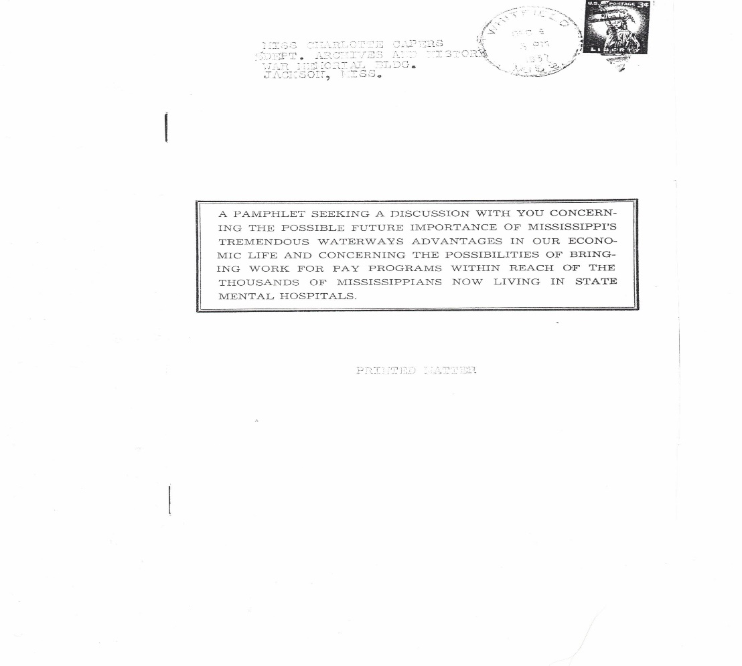
* * *
The following portion of a letter to the editor in the Fred Chaney Papers could not be found in either the Delta Democrat Times or the State Times newspaper but there could have been other newspapers he communicated with for this letter. He signed the letter only as “Observer.” It was most likely mailed to the newspapers. However, a copy of this letter was found in the Fred Chaney Papers at the Department of Archives and History. This document has not been edited.

COPY OF A LETTER APPEARING IN THE STATE TIMES
May 15 AND IN THE DELTA DEMOCRAT TIMES--MAY 16.
Daer Sirs--
…The great NATURAL ADVANTAGE we do have to place in the game of attracting industry and which few states CAN MATCH are the unrivaled water resources that we allow to go undeveloped--UNUSED.
How much longer can we afford to ignore these?
…Noone should have to be an economic expert to see the plain truth that the greatest basic advantages to offer industry must of necessity be (1) cheap and limitless and permanent power supply (2) Permanent and easy means of transport for its products.
By fulfilling only the last mentioned of these fundamental requisites the citizenship of one Miss. County have experienced an unmatched industrial response.
By making available, under a plan of state-sponsored water way resource development cheaply produced power supply and generally located easy transport facilities Mississippians North, East, West, and South might have the same good fortune as have the citizens of Jackson County,---the same proportionate return on their state undertaken waterway projects.
If a state-wide convention is soon to be called, or if a special legislative session is in order it ought to be, let me submit as my own quite questionable personal opinion, dedicated to the long over-due business planning a general program of water resource exploitation as the best chance Mississippi can ever have for getting rapid, EVEN distribution of industrial and increased population benefits.
Whatever the causes may be for rejection further of the idea of making use of the abundant water-way possibilities that God and Nature provided to Mississippians all the way from the Tennessee line down to the Gulf they are not apparent to the Chief Engineer of the U.S. Army, General Itchner nor to Mr. Harvey Firestone Jr. who in recent speeches before the Delta Council Day gathering at Cleveland both told the citizens of this state that their manifest way of destiny toward becoming the wonderful blessed region that in every way our state might become lay in making full use of its greatest NATURAL ADVANTAGES--it’s rivers and ports.
Is it not time then for us to leave off placing our hopes and our faith in the many varying plans of substitute for the certain results that are bound to come if only we recognize what we really are--a great water-blessed state whose very name is the same as that of the World’s greatest River-Mississippi-signed,
OBSERVER

* * *
No further correspondence has been located to support or question Chaney’s waterways proposal. The twelve-page pamphlet was printed but it is unknown whether Hodding Carter, Jr. or Fred Chaney’s mother was involved in the costs, printing, and mailing. It is doubtful if Carter helped or published the document because it was printed with numerous spelling errors with excessive capitalization and bold sentences. Ms. Chaney often copied and printed many of his letters and submitted them to the Delta Democrat-Times and other state newspapers. Fred Chaney had several subjects in the pamphlet that he expounded on, including the waterways advantage, his work-for-pay proposal, and mental hospitalization.
Fred Chaney never specifically noted any rivers in Mississippi or waterways except for the Mississippi River and the Port of Pascagoula. But he did promote state development of Mississippi’s inland waterways, coastal and river ports and the industries that would follow.
* * *
The Pat Harrison Waterway District was created in 1962 to provide flood control, economic development, improved water management, and enhance recreation. The Pearl River Basin Development District was created in 1964. The Pearl River Valley Supply District was created in 1958 to construct and manage the Ross Barnett Reservoir. The Tombigbee River Water Valley Management District was created in 1962 to assist with the U.S. Corps of Engineers and the authorization of the Tennessee-Tombigbee Waterway Project.
The Tennessee-Tombigbee (Tenn-Tom) Waterway was first proposed in the early nineteenth century with the advent of steamboat traffic. The waterway would link the Tennessee and Tombigbee rivers with the Gulf of Mexico. Governor James Plemon Coleman served from 1956-1960 and in his campaign for governor, he “emphasized the need for a new state constitution and the need for continued industrial development.” He “demanded that an aggressive campaign for river and harbor improvement be undertaken.” In 1957 he met with Governor James E. Folsom of Alabama along with legislators from both states and initiated plans for the Tennessee-Tombigbee Project.
It was not until 1972 that the Corps of Engineers began construction of the project. The 234-mile waterway connected the Tennessee River to the junction of the Black Warrior-Tombigbee River and would link commercial navigation to the Gulf of Mexico. The waterway opened in 1985 at a cost of $2 billion and was best known as the “big ditch” by opponents who said that it was engineered by powerful Southern legislators to bring federal dollars to an impoverished region.
The Tenn-Tom Waterway links to 4500 miles of navigable waterways serving mid America and ships as much as 1.2 B ton-miles of commerce each year and “generates more than $8 billion annually in economic benefits and more than 24,000 jobs.”
Mississippi in 2016 was one of two states that did not use hydropower which uses flowing water and turbines and generators at non-powered dams and converts energy into electricity. While Mississippi has several dams, they are non-powered and there is no utility scale hydroelectric generators in the state. According to the U.S. Energy Information Administration (eia) “Mississippi consumes nearly four times more energy than it produces…About 11 in 100 Mississippi households rely on propane as their main heating fuel, more than double the national rate…Mississippi has almost 4% of the nation’s underground natural gas storage capacity…All of the coal mined in Mississippi is lignite, which has a lower heating value than other types of coal…Mississippi has the largest nuclear power reactor by generating capacity in the United States…Biomass and solar energy account for Mississippi’s electricity generation from renewables.”
Brandon Presley, Northern District Commissioner of the Public Service Commission stated, “he was upset with Mississippi consistently ranking near the bottom when it comes to energy efficiency.”
Mississippi could move toward long term energy planning by better utilizing the waterways and resources available. Maybe this is what Fred Chaney was trying to support and promote in 1957.

Charles M. Dollar, Journal of MS History, Vol LXXVIN’1 and No. 2, Spring/Summer 2014, P 31.
Ibid, p 29.
The Port of Pascagoula is the largest seaport in Mississippi with 25 million tons of cargo moving through the port annually. The port is a 42-foot-deep channel on the Pascagoula River.
Reader Says State Is Ignoring Development Of Its Waterways, Letter to the Editor, Delta Democrat-Times, May 16, 1957.
Fred Chaney, Letter to Rep. Karl Weisenburg, June 23, 1957, Fred Chaney Papers, MS Dept. of Archives and History, Jackson, MS.
Fred Chaney, “A Pamphlet Seeking A Discussion With You Concerning The Possible Future Importance of Mississippi’s Tremendous Waterways Advantages In Our Economic Life and Concerning the Possibilities of Bringing Work For Pay Programs Within Reach of the Thousands of Mississippians Now Living In State Mental Hospitals, Fred Chaney Papers, MS Dept. Archives and History, Published date unknown. The pamphlet was postmarked and mailed to the Dept. of Archives and History on Dec. 9, 1957.
Lieutenant General Emerson Charles Itschner was the Chief Engineer of the US Army Corp of Engineers.
Harvey Firestone, Jr. was the Chief Executive Officer of the Firestone Tire and Rubber Company from 1946-1963.
Fred Chaney, Letter to the Editor, Delta Democrat-Times and State Times, May 15 and May 16 May, ND, Fred Chaney Papers, MS Dept. of Archives and History, Jackson.
“A Financial Viability Review of the Pat Harrison Waterway District,” Appendix A: Characteristics of Mississippi’s Major Regional Waterway Districts, Joint Legislative Committee On Performance Evaluation and Expenditure Review, PEER Report #614, December 18, 2017.
David G. Sansing, James Plemon (J.P.) Coleman: Fifty-second Governor of Mississippi: 1956-1960, mshistorynow.mdah.ms.gov
John K. Bettersworth, “Mississippi: A History,” Pgs. 448-449, The Steck Company, Austin, Texas, Copyright 1958.
“2B Tenn-Tom Waterway yet to yield promised boom,” MS Business Journal, September 17, 2019.
Ibid.
www.eia.gov, Renewable energy, July 16, 2020.
Mississippi State Profile and Energy Estimates, Profile Analysis, www.eia.gov, July 16, 2020.
Energywire, www.energynews.us, June 18, 2019.

